Water quality section of sustainability paper

# Methods: (Note: Jeff drafted text that I put in various sections

## 1.1 Sustainability Target Definition

### 1.1.1 Broad definition of sustainability used and why

***Nutrient load from fields per unit area***. Loads on a per area basis are the only metric that makes sense for individual fields in corn-based systems. Proposed numeric water quality criteria are based on concentration, but concentration standards would not allow the sustainability assessment of fields.

* *(Recognize that pesticides, sediment, endocrine disruptors, etc. could have been used, and why nutrients are the most critical. Here we could say why only N and not P, although that could also be in the next section.)*

### 1.1.2 Specific metric(s)

***Nitrate-N loss through tile drainage*** (because that's the only one we have enough data for

### 1.1.3 Sustainability target (numeric goal for the specific metric described above)

## *Nitrate-N loss from state nutrient reduction strategies, avbl in IL, IA, MN, applied to corn cropping system estimate*.

For the purposes of this paper, relative load reductions of 45% for nitrate-nitrogen and total phosphorus were adopted to assess the sustainability of corn-based production systems based on the 2008 Gulf Hypoxia Action Plan recommendation (MR/GMWNTF, 2008). In this context, the 45% reduction can be viewed as a sustainable water quality level. Each state used the best available information for determining state specific targets for N and P based on local climate and agricultural practices (Table X).

More possible text from Jeff.

The hypoxic zone, which forms each summer in the Northern Gulf of Mexico, has been linked to excess nutrients, mainly nitrogen and phosphorus, primarily exported from agricultural production areas in the Mississippi River Basin (MRB) (MR/GMWNTF, 2008). The 2008 Gulf Hypoxia Action Plan called for the 12 states within the MRB to produce plans to reduce nutrient delivery to the Gulf of Mexico by 45%. States including Illinois, Iowa and Minnesota have responded to the need to meet nutrient reduction goals within their states and beyond state boarders by developing nutrient reduction strategies (IDALS, IDNR, & ISU, 2013; MPCA, 2014; IEPA, & IDOA, 2015). For specific details on state nutrient reduction strategies, methods and assumptions please see the respective state strategy documents as referenced.

Development of a statewide, voluntary nutrient reduction strategies involved scientific and economic assessment of practices with potential to achieve nutrient reduction goals. The assessment involved establishing baseline conditions, reviewing scientific literature to assess potential performance of practices, estimating potential load reductions of implementing various scenarios involving nutrient reduction practices, and estimating implementation costs. Practice categories included: management practices (e.g. fertilizer timing and rate and cover cropping) land use practices (e.g. perennial crops, crop rotation, tillage method and conservation reserve programs) and edge-of-field practices (controlled drainage, wetlands, bioreactors and buffers).

And previous phone call discussion: The reason to use this is that there have been a large number of people who have been debating reductions for at least a decade and a consensus has formed on what the goals should be. So rather than coming up with new values, we will adopt what the group has already done. A large body of work exists that forms a good basis.

## 1.2 Data Sources

To assess the sustainability of corn production systems from a water quality standpoint, information was gathered from existing sources.

### CSCAP database

o   Explain database (possibly done in other sections of this paper)

o   We are including free drainage and controlled drainage sites

o   Explain sites, fact that we combine all plots with one treatment into one “site” for this.

### MANAGE database section drafted by Gio:

*Add CSCAP data description*

The Managed Annual Nutrient loads from AGricultural Environment (MANAGE) database is a readily-accessible database compiling measured field-scale annual nitrogen and phosphorus load data along with pertinent management and site characteristic metadata collected across the United States and Canada (need references).

The database contains 1279 site-years (*actually, plot-years*) of data from 91 studies on artificially drained agricultural lands, including both surface and subsurface drainage types. Considering water quality sustainability criteria/metric defined earlier, for this analysis we only included studies conducted in “Corn Belt” states that partially or fully drain to Mississippi, hence to the Gulf of Mexico (in particular: IA, IL, IN, MO, MN, OH). Selected data was further reduced to include the results from the sites/plots with corn being part of their crop-rotation and having subsurface drainage with no inlets. Subsequently, derived dataset contained 677 site-years of data from 39 studies spanning from 1969 to 2012. Studies from Iowa made up the most of the data contributing about 60% of site-years, followed by Illinois and Minnesota with 16 and 14% respectively (Fig. X).

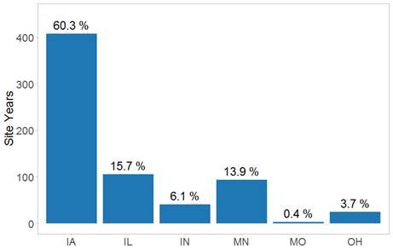

Figure x: Data in the MANAGE database from sites having subsurface drainage but no surface inlets, in Corn Belt states.

* *Only included “Corn Belt” states that have parts draining to Gulf because of our definition of sustainability (45% reduction)*
* *Used free drainage with no inlets to look at conventional systems*

## 1.3 Comparison to target

•    Explain the cumulative probability method or any other way we make the comparison (this section may not be needed; maybe just in Results).

•   Second question was, if existing system will not meet the goal (is not sustainable), what if we implemented various practices? Cover crops, controlled drainage. Our questions is “Can water quality loads be made sustainable within the cropped field?” so we will focus on in-field practices. If goal cannot be met with these, then need to look at edge-of-field practices, but they are not reviewed here.

# 2. Results

## 2.1 Sustainability targets

The water quality sustainability metrics, in the form of nitrate-N and phosphorus loads for corn-based cropping systems, differ among the three states (Table 1). This might be due to … (I still haven’t checked with people who calculated in Minnesota and Illinois whether they agree with the way I calculated, so these are not too certain. )(But once results are finalized, what else can we say about these values? Laura, is this where we would include USGS load estimates?

We delete P, right?

|  |  |  |
| --- | --- | --- |
| State | Sustainable Nitrate-N Load (kg/ha) | Sustainable Phosphorus Load (kg/ha) |
| Illinois | 8.0 | 0.48 |
| Iowa | 17.1 | 0.69 |
| Minnesota | 6.6 | 0.32 |

## 2.2 Comparison of drained fields to water quality sustainability targets

The nitrate-N load cumulative frequency curves for the CSCAP and MANAGE databases both show that nitrate-N and phosphorus loads from drained corn-based cropping systems usually exceeds these sustainability metrics (Figure 1). The smoother curve for the MANAGE database is due to the larger number of site years. There are 180 in the MANAGE database from 39 sites, while there are 23 in the CSCAP database from 5 sites. The median load (50% probability) for the CSCAP database is 32 kg/ha which is higher than the median of 26 kg/ha in the MANAGE database, although at higher loads the position of the two curves is reversed.

There are 11 site years with NO3-N loads greater than 60 kg/ha in the MANAGE database. 8 of them were originated from the studies in northern and southern parts of IA and MN, respectively, while 6 of them occurred within the same two years (1990 and 1991). High N loads in all these case were largely attributed to unusual seasonal or annual precipitation patterns; in particular (a) wet years following the dry period with virtually no or very little tile flow, or (b) very wet spring conditions causing up to 80% of the NO3-N losses occurring by early June.

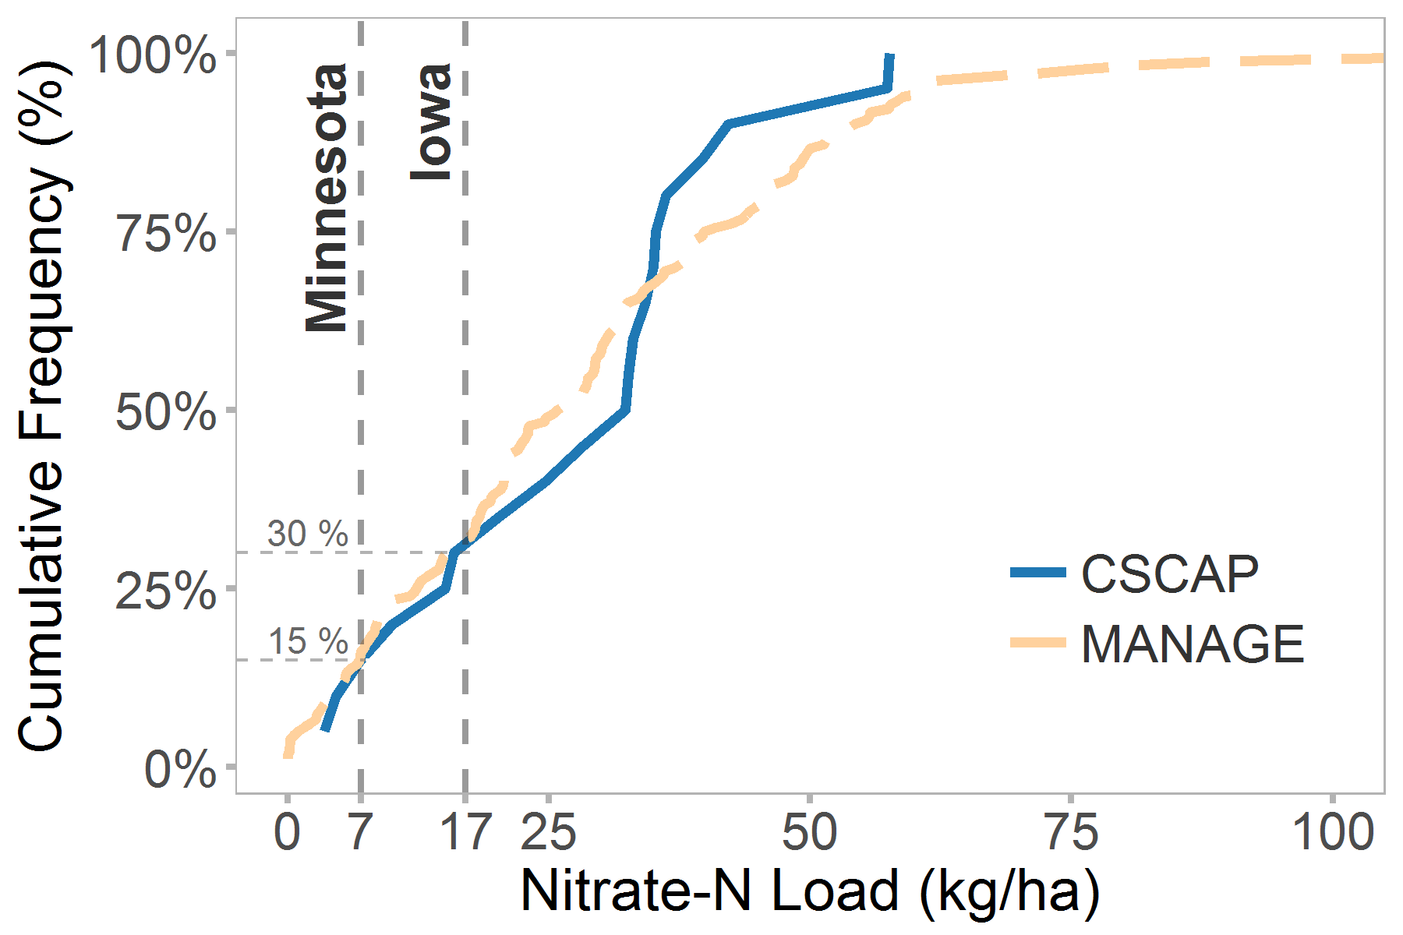

For discussion – does this have the right elements? For discussion:

1. Y Axis label: Cumulative frequency? Percent less than?
2. Site years (top) or plot years (bottom)?

Any problem dividing all plots, as below?

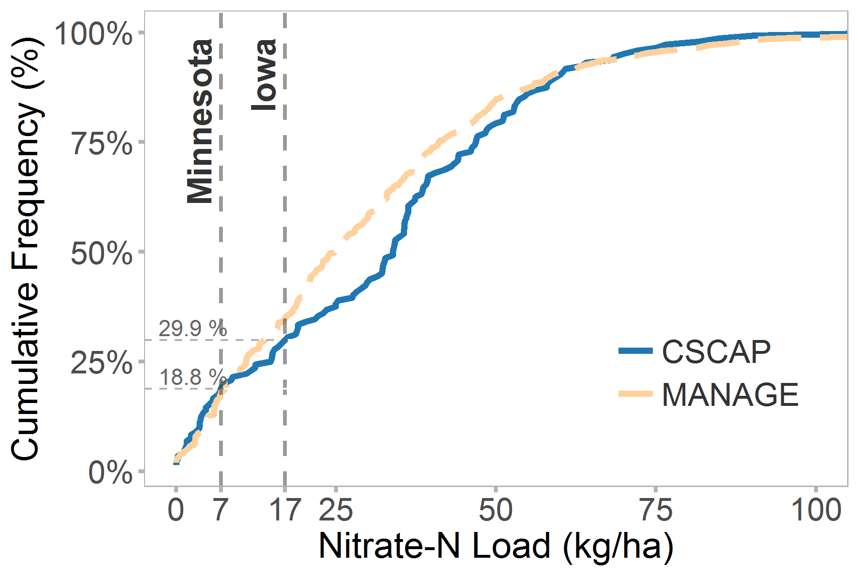

Figure 1: Cumulative frequency of nitrate-N loads for all site years, with three sustainability metrics

Need to rename Y axis

Just 15% of site-years in both the CSCAP and MANAGE databases had nitrate-N losses less than the Minnesota sustainability metric, while 30% of site-years were less than the Iowa metric.

The fact that only 15% of site years in these two databases met the sustainability targets does not necessarily represent the percentage of all fields in the region that meet those targets. However the measured sites used normal agricultural practices (reference(s) for this?). There is no reason to assume that this sample is biased high or low.

Weather plays an important role in determining nitrate-N losses in any single year (Figure 2). Almost all sites (xx%) would have met the sustainability targets in 2012, when precipitation was low across the entire Corn Belt. However, in 2015, a moderately wet year, only __% would have met the Iowa target and __% would have met the Minnesota target.

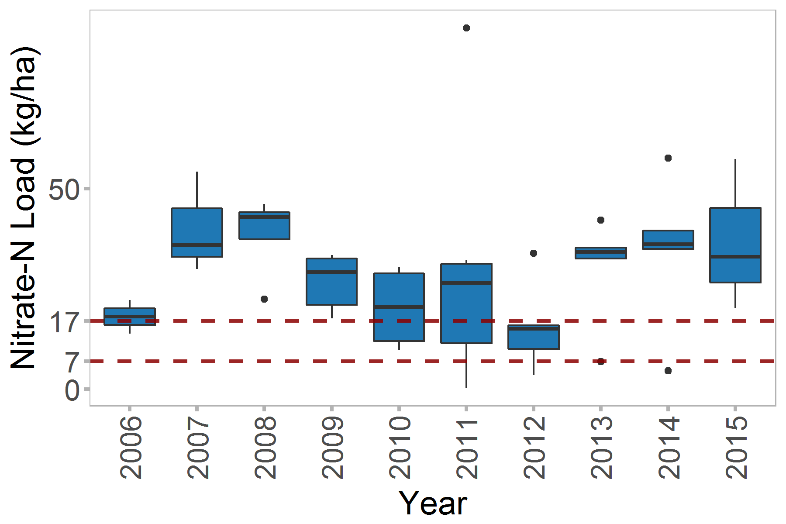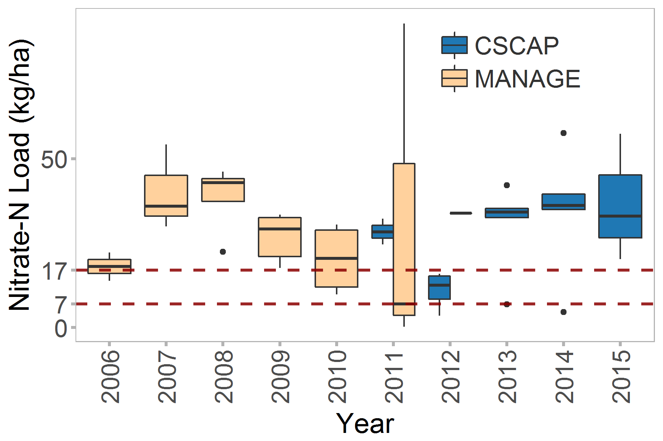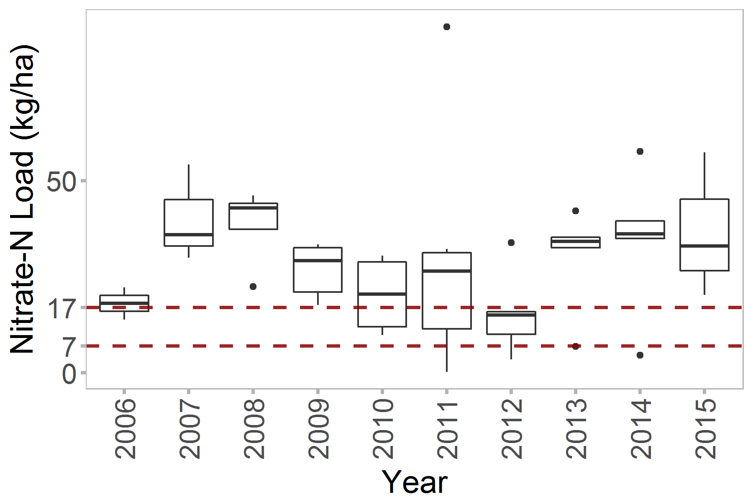

Keep the top one, make boxes transparent (no fill)

Figure 2: Differences in nitrate-N loads in the CSCAP and MANAGE databases by year for the most recent 10 years (Question – should databases be separated? Major difference in 2011. Purpose is pointing out that in some years, most sites met criteria)

## 2.3 Potential for meeting sustainability targets with changes in agricultural practices

Adequate data for comparing the distribution were available for only one practice: controlled drainage. The cumulative frequency of monitored site years for controlled drainage is to the left of those for free drainage (Figure 3), meaning that loads are lower at all points in the distribution.

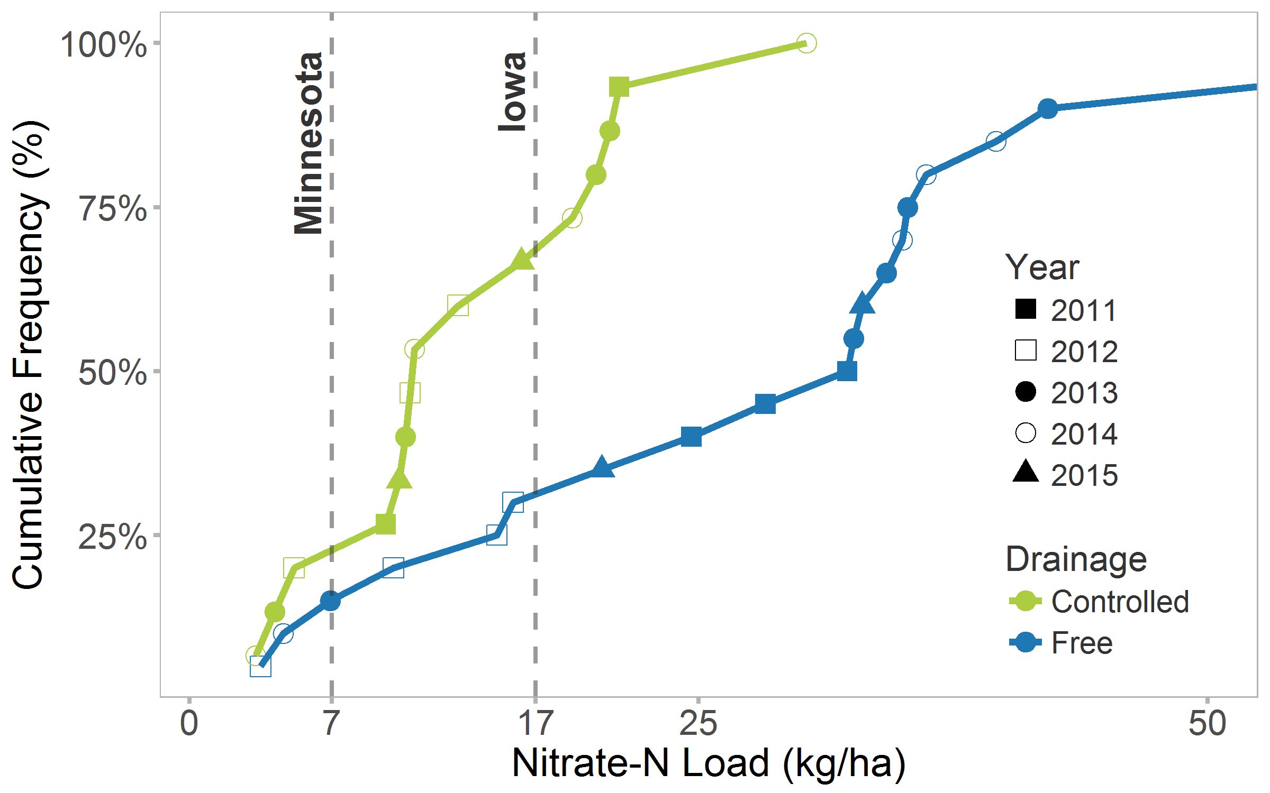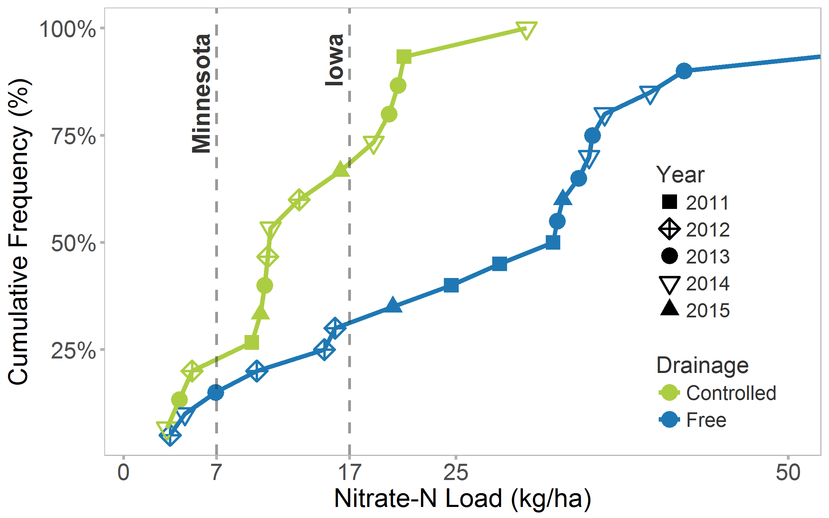

Figure 3: Potential reduction in nitrate-N losses with controlled drainage (note CSCAP data only included, and also addition of markers although 2012 and 2014 are hard to see)

Other practices have been evaluated for their potential to reduce nitrate and phosphorus in the nutrient reduction strategies. These have generally used studies in locations adjacent to the states where used, and the distribution represents the site years included in those studies. (Do we need to give a reason we can’t plot those like above. Too few site years? Too limited areas?)

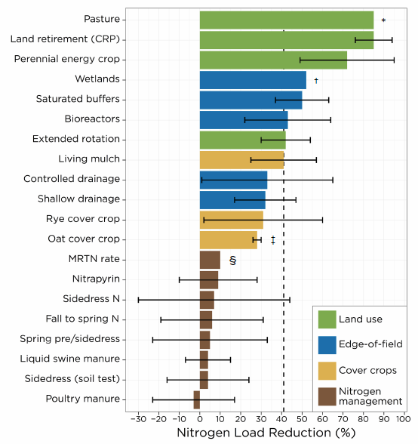

Figure 4: Potential reductions from other practices. [Maybe replot horizontally?, or do we need to include all the states?

Here is the comparison of all the practice reduction percentages, from Reid Christianson’s comparison ( http://owl.cwp.org/mdocs-posts/upper-mississippi-nutrient-loss-reduction-strategies/) Should we somehow graph that? **For Discussion**.

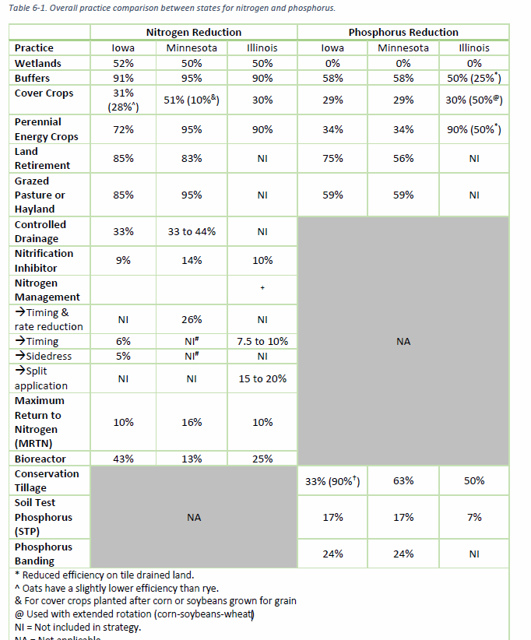

# Limitations and Discussion

Data included in this section were not collected with the purpose of this comparison, and thus statistically issues are unavoidable. However these data represent a wider sample of sites than have previously been presented together, and thus the benefits of the comparison were considered to override the limitations. Nevertheless, the following limitations should be kept in mind:

* The CSCAP sites all collected data from 2011 to 2015. Sites in the MANAGE database collected data over a wide variety of years (from 1969 to 2012) and thus differences include the differences in years.
* The CSCAP sites were part of one project, and an effort was made to collect comparable data (Kladivko et al., 2014). Even so, differences remain in methodology, potentially limiting the quality of comparisons. Sites in the MANAGE database differ even more. (Do they have a statement about limitations? Maybe something from paper.)
* Any others?

Data used in this section show that under current conventional management, corn-based systems in drained area are not sustainable from a water quality standpoint. . If we implement practices they have the potential to meet sustainability targets, although the level of changes will need to be high.

An overriding problem in estimating water quality impacts and sustainability is the lack of knowledge of the extent of drainage, which has an extremely high impact on nutrient losses. The ARMS corn survey in 2016 for the first time asked detailed questions about drainage including controlled drainage, in a well-design sample. These data will be available in 2018 and may be able to greatly expand our knowledge about .

## References

Kladivko, E.J., Helmers, M.J., Abendroth, L.J., Herzmann, D., Lal, R., Castellano, M.J., Mueller, D.S., Sawyer, J.E., Anex, R.P., Arritt, R.W. and Basso, B., 2014. Standardized research protocols enable transdisciplinary research of climate variation impacts in corn production systems. *Journal of Soil and Water Conservation*, *69*(6), pp.532-542.

IDALS, IDNR, & ISU. 2013. Iowa Nutrient Reduction Strategy: A science and technology-based framework to assess and reduce nutrients to Iowa waters and the Gulf of Mexico. Retrieved from <http://www.nutrientstrategy.iastate.edu/sites/default/files/documents/NRSfull-130529.pdf>

IEPA, & IDOA. 2015. Illinois Nutrient Loss Reduction Strategy. Retrieved from Springfield, IL: <http://www.epa.illinois.gov/Assets/iepa/water-quality/watershed-management/nlrs/nlrs-final-revised-083115.pdf>

Mississippi River/Gulf of Mexico Watershed Nutrient Task Force. 2008. Gulf Hypoxia Action Plan 2008 for Reducing, Mitigating, and Controlling Hypoxia in the Northern Gulf of Mexico and Improving Water Quality in the Mississippi River Basin. Washington, DC.

MPCA. 2014. The Minnesota Nutrient Reduction Strategy. Retrieved from <https://www.pca.state.mn.us/sites/default/files/wq-s1-80.pdf>

Strock, J.S., G.R. Sands, and M.J. Helmers. 2011. Subsurface Drainage Design and Management to Meet Agronomic and Environmental Goals. p. 199-208. *In* J.L. Hatfield and T.J. Sauer (ed.) Soil Management: Building a Stable Base for Agriculture. ASA-SSSA, Madison, WI.